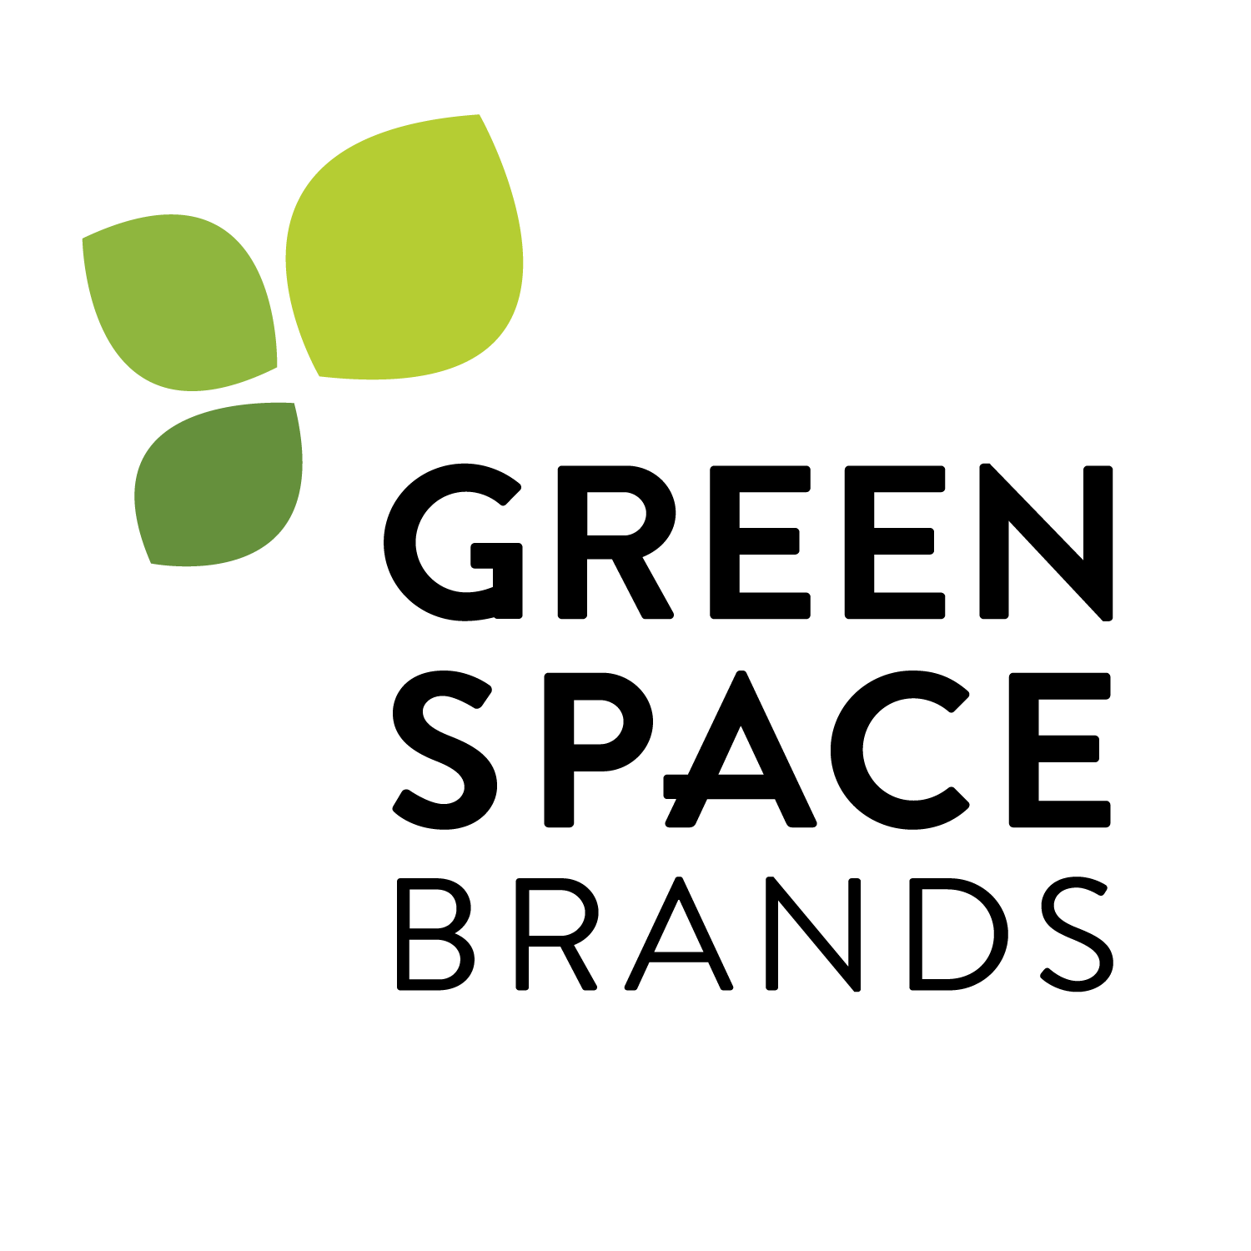
FOR IMMEDIATE RELEASE

GreenSpace Brands Inc. Reports Highest Quarterly Revenue in History with Second Quarter Revenue Growth of 129%

TORONTO, ONTARIO, November 26, 2015 – GreenSpace Brands Inc. ("GreenSpace" or “the Company”) (TSXV: JTR) today reported its second quarter financial results for the three and six month periods ended September 30, 2015.

Consolidated Performance Summary

1 – These are not measures of financial performance under IFRS. These measures are not necessarily comparable to similarly titled measures used by other companies and should not be construed as an alternative to net income or cash flow from operating activities as determined in accordance with IFRS. See the discussion included in the Company’s second quarter MD&A available on www.sedar.com on non-IFRS disclosure for further details, including reasons for presentation of these financial measures.

The second quarter revenue results for the Company continued to be strong, showing a 129.0% increase in the quarter compared to prior year, achieving its largest quarter in sales by a significant amount. The strong revenue results were primarily from revenue being contributed by newly launched brands (Nudge and Kiwi Pure) and newly introduced Rolling Meadow product lines of yogurt, butter and kefir. These new brands and products continued to build on their strong sales momentum in the current quarter and none were part of the Company’s product offering in the comparative quarter from fiscal 2015. As well, the Company’s Life Choices product line experienced its largest sales quarter in its 13-year history due to increased customer demand, a larger number of retailers carrying the product and newly establish national distribution. All of the Company’s new brands and new product offerings have been extremely well received and customer demand continues to build momentum quarter-over-quarter.

As anticipated, gross profit margins in the quarter were lower than the comparable period due to a larger proportion of revenue coming from Rolling Meadow fluid milk products, increased trade spending to launch and support new brands and start-up costs associated with the launch of Nudge and the new Rolling Meadow product lines of vanilla yogurt and kefir. As well, the Company experienced higher than expected inventory write-offs in the quarter as a result of increasing its fluid milk orders in anticipation of a large Canadian retailer indicating they were going to begin ordering the product. As typically happens in the industry, the retailer was delayed in making their first order and didn’t start the anticipated regular order patterns until October 2015. Normalizing for the higher levels of inventory write-offs management believes margins in the quarter would have improved by 2.1% in the second quarter and 1.8% year to date.

As the Company is in its growth phase and is continuing to invest in developing new brands, launching new products and building its presence in the Canadian organic and natural food market, it was not unexpected that SG&A expenses increased in the second quarter and year to date in fiscal 2016 compared to prior year. The Company continues to invest in promoting and supporting the Company’s new brands. Storage and distribution expenses have also increased in proportion to revenue due to increased storage for the larger number of brands and a number of new products attaining national distribution. As well, the Company incurred significant professional service costs in the current quarter and year-to-date on acquisition due diligence and to complete its going-public qualifying transaction. These incremental professional service costs are not expected to reoccur under normal operations in future periods.

Outlook

Management continues to believe that there are a number of fundamental trends occurring within both the global and North American food market, which will inevitably drive demand for the Company's brands and products in future periods. As reported by the 2014 NPN Journal Industry Report, organic food sales are growing at an annual rate of 14% as compared to conventional food sales growing at an annual rate less than 2%. Presently, organic food sales make up only 6% of consumer food purchases but with these varying growth rates, it is expected that organic and natural sales take a much larger portion of consumer food purchases over the next five years. Considering this the 2014 NPN Journal Industry Report expects that the Global organic food market will reach $210 billion by the year 2020 and over the next five years that market will have a cumulative average growth rate of 15.7%.
With these trends in mind, Management continues to be optimistic that this anticipated growth in the organic and natural food market will continue to drive demand for the Company’s developed products and provides a lot of opportunity for further expansion into new product offerings and within existing brands. The combination of the Company’s inherent strengths and exposure to these growing markets provides good fundamentals to support long-term growth in all of the Company’s product lines. The Company’s strong customer relationships, existing extensive distribution networks, well-recognized and respected brands and efficient operations further supports this fundamental market growth.
In particular, management believes it is one of very few companies positioned to capitalize on the emerging grass-fed trend in Canada. Through its dairy brand, Rolling Meadow, and the Life Choices brand, the Company has carved out a niche in the Canadian grass-fed market, which it hopes to exploit with continued product and brand launches.
The Company intends to continue to grow through a two pronged growth strategy. Firstly, the Company expects to have strong and on-going internal brand and product development. There are currently a number of new product offerings in various stages of development that will be released to market before the end of the current fiscal year. Secondly, the Company expects to grow through acquisition by making strategic investments in strong, simple ingredient businesses. The Love Child acquisition completed subsequent to quarter-end is a great example of the type of business that the Company is looking to acquire. Through the Company's strong customer relationships and existing extensive distribution networks management expects to increase and diversify Love Child’s revenue and recognize a number of selling, general and administrative expense efficiencies, improving the overall profitability of the acquired business.
Management feels it is in a strong position to be one of the principle consolidators in the North American natural and organic food market, due to its industry position and accumulated reputational goodwill within the industry.
As it grows, the Company will focus on cost containment, margin enhancement and cash-flow management to offer innovative new products with healthy attributes. By integrating various brands, new products and strategic acquisitions, GreenSpace aims to achieve economies of scale and continue to enhance its overall market penetration.
About GreenSpace Brands Inc.

GreenSpace is a Canadian-based brand ideation team that develops, markets and sells premium natural food products to consumers across Canada. GreenSpace owns Rolling Meadow Dairy, Canada's first grass fed dairy product line that has built upon the founding values of Greenspace's original brand, Life Choices. Life Choices features premium convenience meat products made with grass fed and pasture raised meats without the use of added hormones and antibiotics. GreenSpace owns Holistic Choice, a premium natural pet food line and Nudge, a line of family favorite foods made better. GreenSpace also owns Love Child (Brands) Inc. a producer of 100% organic food for infants and toddlers made with the purest, natural and most nutritionally rich ingredients. All brands are wholly owned and retail in a variety of natural and mass retail grocery locations across Canada.

For more information, visit www.greenspacebrands.ca. GreenSpace's filings are also available at www.SEDAR.com.

Forward-Looking Statements

Certain statements in this press release constitute forward-looking statements within the meaning of applicable securities laws. Forward-looking statements include, but are not limited to, statements made under the heading “Outlook” and other statements concerning the Company’s 2016 objectives, strategies to achieve those objectives, as well as statements with respect to management’s beliefs, plans, estimates, and intentions, and similar statements concerning anticipated future events, results, circumstances, performance or expectations that are not historical facts. Forward-looking statements generally can be identified by the use of forward-looking terminology such as “outlook”, “objective”, “may”, “will”, “expect”, “intend”, “estimate”, “anticipate”, “believe”, “should”, “plans” or “continue”, or similar expressions suggesting future outcomes or events. Such forward-looking statements reflect management’s current beliefs and are based on information currently available to management. Forward-looking statements involve risks and uncertainties that could cause actual results to differ materially from those contemplated by such statements and there can be no assurance that actual results will be consistent with these forward-looking statements. Factors that could cause such differences include the cyclical nature of the construction and agriculture industries, changes in general economic conditions and interest rates, adverse weather, cost and availability of materials used to manufacture the Company’s products, competitive developments, legislative and government policy changes, as well as other risk factors included in the Company’s Annual Information Form dated November 9, 2015 under the heading “Risks and Uncertainties Related to the Business” and as described from time to time in the reports and disclosure documents filed by the Company with Canadian securities regulatory agencies and commissions. This list is not exhaustive of the factors that may impact the Company’s forward-looking statements. These and other factors should be considered carefully and readers should not place undue reliance on the Company’s forward-looking statements. As a result of the foregoing and other factors, no assurance can be given as to any such future results, levels of activity or achievements or levels of dividends and neither the Company nor any other person assumes responsibility for the accuracy and completeness of these forward looking statements. The factors underlying current expectations are dynamic and subject to change. Certain statements included in this press release may be considered “financial outlook” for purposes of applicable securities laws, and such financial outlook may not be appropriate for all purposes. All forward-looking statements in this press release are qualified by these cautionary statements. The forward-looking statements contained herein are made as of the date of this press release and except as required by applicable law, the Company undertakes no obligation to publicly update or revise any forward-looking statement, whether as a result of new information, future events or otherwise.
Neither the TSX Venture Exchange nor its regulation services provider (as that term is defined in the policies of the TSX Venture Exchange) accepts responsibility for the adequacy or accuracy of this release.
__________________________________________________________________________________
For more information, please contact:
Matthew von Teichman | Mathew Walsh
President & Chief Executive Officer | Chief Financial Officer
GreenSpace Brands Inc. | GreenSpace Brands Inc.
Tel: (416) 934-5034 Ext. 235 | Tel: (416) 934-5034 Ext. 222

